**Create the data and the control dependence graphs for the following program. Use single statements for the nodes of the graph.**

public int pay(int price, int numTickets, boolean applyDiscount, boolean applyVat) {  
 int DISCOUNT_RATE = 20; //Percent  
 int VAT = 22; //Percent  
 int payment = numTickets * price;  
 if (applyDiscount) {  
 int discount = (payment * DISCOUNT_RATE) / 100;  
 payment = payment - discount;  
 }  
 if (applyVat) {  
 payment = payment + ((payment * VAT) / 100);   
 }  
 return payment;  
}

DATA DEPENDENCE GRAPH:

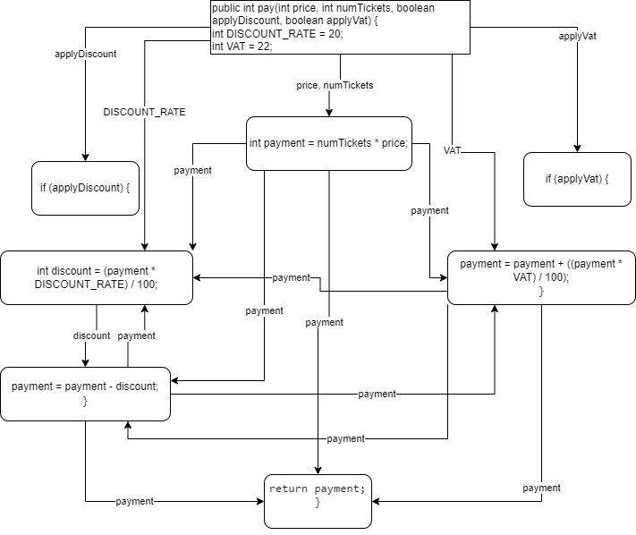

CONTROL DEPENDENCE GRAPH:

